**Project Proposal**

**Hospital Management System**

**Submitted By**

**Md. Anamul Haque**

Roll: MUH2011035M

Session: 2019-20

Project Supervisor

**Tanvir Zaman Khan**

Assistant Professor

Department of Information and Communication Engineering

NOAKHALI SCIENCE AND TECHNOLOGY UNIVERSITY

INFORMATION & COMMUNICATION ENGINEERING

Noakhali-3814

Bangladesh

**Date: 27th January, 2025**

**DECLARATION**

This project proposal is submitted to the Department of Information and Communication Engineering (ICE), Noakhali Science and Technology University, Noakhali-3814, in partial fulfilment of the requirement for having the B.Sc. degree in ICE under the course entitled with “ICE-4110”. So, I, here by declare that this project proposal has not been submitted elsewhere for the requirement of any kind of degree, diploma or publication.

**Md. Anamul Haque**

Roll No: MUH2011035M

Session: 2019-20

Year: 4, Term: I

Department of Information and Communication Engineering

Noakhali Science and Technology University,

Noakhali-3814.

**Acceptance**

This project proposal is submitted to the Department of Information and Communication Engineering (ICE), Noakhali Science and Technology University, Noakhali-3814, in partial fulfilment of the requirements for having the B.Sc. degree in ICE under the course entitles “ICE-4110”.

**Tanvir Zaman Khan**

Assistant Professor

Department of Information and Communication Engineering

Noakhali Science and Technology University,

Nokhali-3814

**Abstract**

The goal of the Hospital Management System (HMS) project is to create a scalable, user-friendly, and effective solution that will improve patient care, administrative efficiency, and hospital operations. In order to make patient registration, appointment scheduling, medical records administration, billing, inventory control, and reporting easier, the suggested system will combine a number of modules. In order to facilitate smooth communication between departments like outpatient, inpatient, pharmacy, and laboratory, this project will make use of contemporary technologies to give real-time access to vital data. To guarantee data protection and adherence to healthcare rules, the HMS will include technologies such as electronic health records (EHR), automatic reminders, and protected access. Reducing manual paperwork, eliminating errors, maximizing resource usage, and enhancing the overall patient experience are among the project's main goals. To provide effective data management and operational transparency, the system would grant role-based access to various users, such as physicians, nurses, administrative personnel, and patients. Through streamlined procedures and data-driven insights, healthcare professionals may improve decision-making, service delivery, and healthcare outcomes by putting this hospital management system into place. It is anticipated that the suggested approach will greatly improve the hospital's accuracy, efficiency, and standard of care.

**Table of Contents**

**Page No.**

**Abstract i**v

**List of Figures** vii

**Chapter 1 INTRODUCTION 1**

1.1 Introduction 1

1.2 Background Study1

1.3 Problem Statement 2

1.4 Motivation 2

1.5 Objectives3

**Chapter 2 LITERATURE REVIEW 4**

2.1 Introduction 4

2.2 Manual System 4

2.3 Related Work 5

**Chapter 3 METHODOLOGY 17**

3.1 Requirement Engineering 17

3.2 Proposed Process Model17

3.3 Technology and Tools18

3.4 Use Case Diagram 23

3.5 E-R Diagram 24

3.6 Testing 25

3.7 Maintenance 25

**Chapter 4 Expected Output 26**

**Chapter 5 CONCLUSION 29**

5.1 Conclusion 29

5.2 Future Work 29

**References 31**

**LIST OF FIGURES**

**Figure Title Page No.**

Figure 2.1 BIRDEM General Hospital 5

Figure 2.2 Square Hospital 6

Figure 2.3 Evercare Hospital Dhaka 7

Figure 2.4 Dhaka Medical College Hospital 8

Figure 2.5 Bangladesh Specialized Hospital 9

Figure 2.6 Apollo Imperial Hospitals 10

Figure 2.7 Prime Hospital Ltd. 12

Figure 2.8 All India Institute of Medical Sciences 13

Figure 2.9 Mayo Clinic in Rochester, Minnesota. 14

Figure 3.1 Agile Software Development Model. 18

Figure 3.2 Use Case Diagram Web based hospital management System 23

Figure 3.3 ER diagram of Hospital Management System 24

**List of Table**

**Table Title Page No.**

Table 2.1 A summary of related project on HMS 16

**Chapter 1**

**INTRODUCTION**

**1.1 Introduction**

The field of healthcare continues to evolve and technology is essential to raising the standard and accessibility of medical care. To successfully manage hospital operations, such as patient care, medical records, staff administration, billing, inventory, and appointments, a Hospital administration System (HMS) is necessary. An HMS streamlines administrative procedures, lowers errors, and enhances service delivery by combining several hospital operations into a single platform. The goal of this project is to create an HMS that will help healthcare organizations successfully and efficiently manage their daily operations. To handle the growing number of patients, regulatory compliance, and the requirement for data-driven decision-making, the healthcare industry must now embrace digital solutions. Hospitals may improve service quality, streamline operations, and guarantee adherence to rules and standards for healthcare with the support of a strong HMS. HMS solutions also offer scalability to accommodate hospital expansion requirements and future technological developments. To ensure a smooth information flow, the system would integrate capabilities like cloud storage, AI-driven analytics, and interoperability with outside healthcare providers.

**1.2 Background Study**

Operational maintenance and management present a number of difficulties for hospitals and other healthcare institutions. Conventional manual procedures for inventory management, billing, record-keeping, and patient registration are laborious and prone to human mistake. An efficient hospital management system guarantees the seamless exchange of information between departments, eliminates redundancies, and provides automation. Better healthcare service management is made possible by digital solutions brought about by technological breakthroughs. Any healthcare organization's success depends on the integration of scheduling software, financial tools, electronic medical records (EMR), and other hospital activities. Though many of the HMS solutions are not customizable to meet the unique requirements of different hospitals or healthcare environments, some do exist. This emphasizes the necessity of an all-encompassing, effective system that is customized to the particular needs of the institution. Additionally, digital systems need to be secure and compliant to meet laws like as the Health Insurance Portability and Accountability Act (HIPAA) and the General Data Protection Regulation (GDPR). Using an HMS to safeguard patient privacy and data security can help hospitals meet these objectives.

**1.3 Problem Statement**

Despite the adoption of digital technologies in healthcare, many hospitals still rely on outdated manual processes or isolated systems that do not effectively communicate with each other. This leads to inefficiencies, errors in patient data handling, delayed appointments, billing issues, and suboptimal resource utilization. The lack of an integrated solution impacts patient care and increases operational costs, ultimately affecting the quality of services provided.

Key issues identified include:

* Fragmented data management leading to miscommunication and redundancy.
* Long patient waiting times due to inefficient scheduling.
* Difficulty in tracking and managing hospital resources.
* High operational costs resulting from manual processes and errors.
* Inability to leverage advanced analytics for better decision-making.

The proposed Hospital Management System will address these problems by offering an all-encompassing solution that integrates different hospital functions, improves operational efficiency, and ensures better care for patients.

**1.4 Motivation**

The motivation behind developing this Hospital Management System stems from the increasing need for automation and integration in healthcare settings. With the growing demand for quality healthcare, it is crucial to streamline hospital operations to manage resources effectively and provide better patient outcomes.

As a key player in healthcare administration, it is essential for hospitals to embrace technology to address challenges such as:

* Inaccurate patient records
* Lengthy manual billing processes
* Inefficient appointment scheduling
* Difficulty in managing inventory and staff workloads
* Lack of interoperability with other healthcare providers

The implementation of an HMS will:

* Improve hospital workflow and productivity.
* Minimize medical errors and enhance patient safety.
* Facilitate better communication and coordination among departments.
* Provide real-time data access for timely decision-making.
* Support telemedicine and remote consultation services.

This system will not only enhance hospital management but also empower healthcare providers with tools to improve patient care, reduce errors, and increase patient satisfaction. By automating hospital processes, the system will lead to significant cost savings and improved patient outcomes.

**1.5 Objectives**

The project's goals are:

* To manage patient registration and record patient information efficiently.
* To generate bills and manage financial transactions.
* To ensure efficient patient data management.
* To streamline hospital operations.
* To enhance patient experience.
* To improve financial management.
* To achieve effective resource and inventory control.
* To ensure data security and compliance.
* To integrate with other healthcare systems.
* To provide decision support through analytics.
* To reduce paperwork and manual errors.
* To ensure scalability for future expansion.

**Chapter 2**

**LITERATURE REVIEW**

**2.1 Introduction**

An extensive analysis of current hospital management systems reveals a diverse range of functionalities and challenges. The literature highlights the evolution of HMS, including traditional systems and modern digital platforms aimed at improving hospital workflows.

Hospital Management Systems (HMS) have evolved from simple administrative tools to complex integrated systems that support clinical, financial, and operational functions. The increasing demand for efficiency, accuracy, and regulatory compliance has driven the adoption of advanced digital solutions across healthcare facilities.

**2.2 Manual System**

Manual hospital management is often characterized by inefficiencies such as:

* Difficulty in retrieving patient records.
* High risk of data loss or duplication.
* Time-consuming billing and scheduling processes.
* Increased administrative workload leading to resource inefficiency.
* Limited scalability and inability to handle growing patient data.
* Lack of real-time updates and tracking.

Despite the simplicity of manual processes, they present significant challenges in terms of scalability, security, and overall operational efficiency. The transition to digital systems offers numerous benefits in addressing these limitations.

**2.3 Related Work**

## [1] BIRDEM General Hospital, located in Dhaka, Bangladesh, is the Bangladesh Institute of Research and Rehabilitation in Diabetes, Endocrine, and Metabolic Disorder. This website is use for the patient to choice the service that required for the diabetes patients. A website that serves most number of diabetes patients.

## 

Fig 2.1: Home Page of BIRDEM General Hospital.

[2] SQUARE Hospitals Ltd, was established with the goal of providing people with goods and services that improve their quality of life. With a culture of innovation, SQUARE is establishing global corporations with substantial investments across the globe. The association has grown to include enterprises in a variety of industries, including media, consumer goods, healthcare, textiles, and information technology.

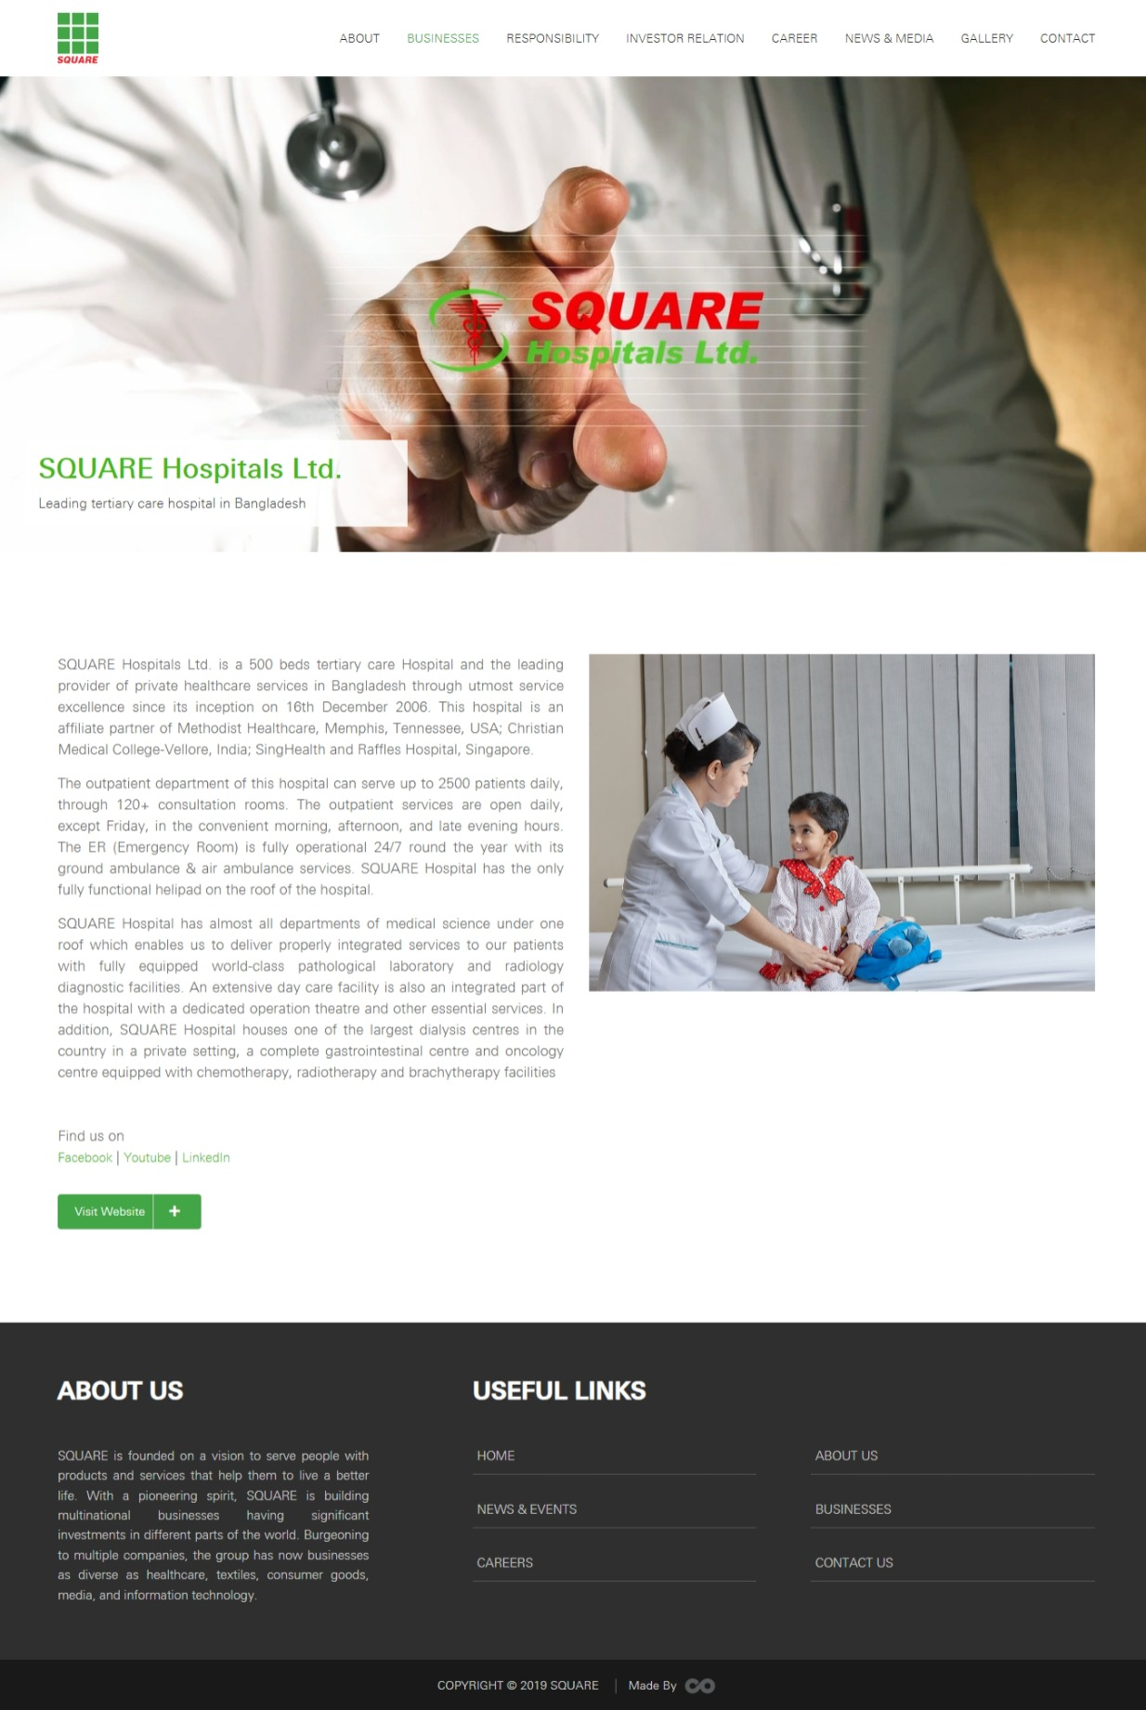

Fig 2.2: Square Hospital website

[3] The first hospital in Bangladesh to receive JCI accreditation is Evercare Hospital Dhaka, a 425-bed multidisciplinary super specialized tertiary care facility. A U.S.-based accrediting organization, The Joint Commission International (JCI) is committed to enhancing healthcare safety and quality globally. This hospital employs top-notch doctors, skilled nurses, and technicians in the majority of medical specialties, and it has the newest diagnostic tools and technologies.

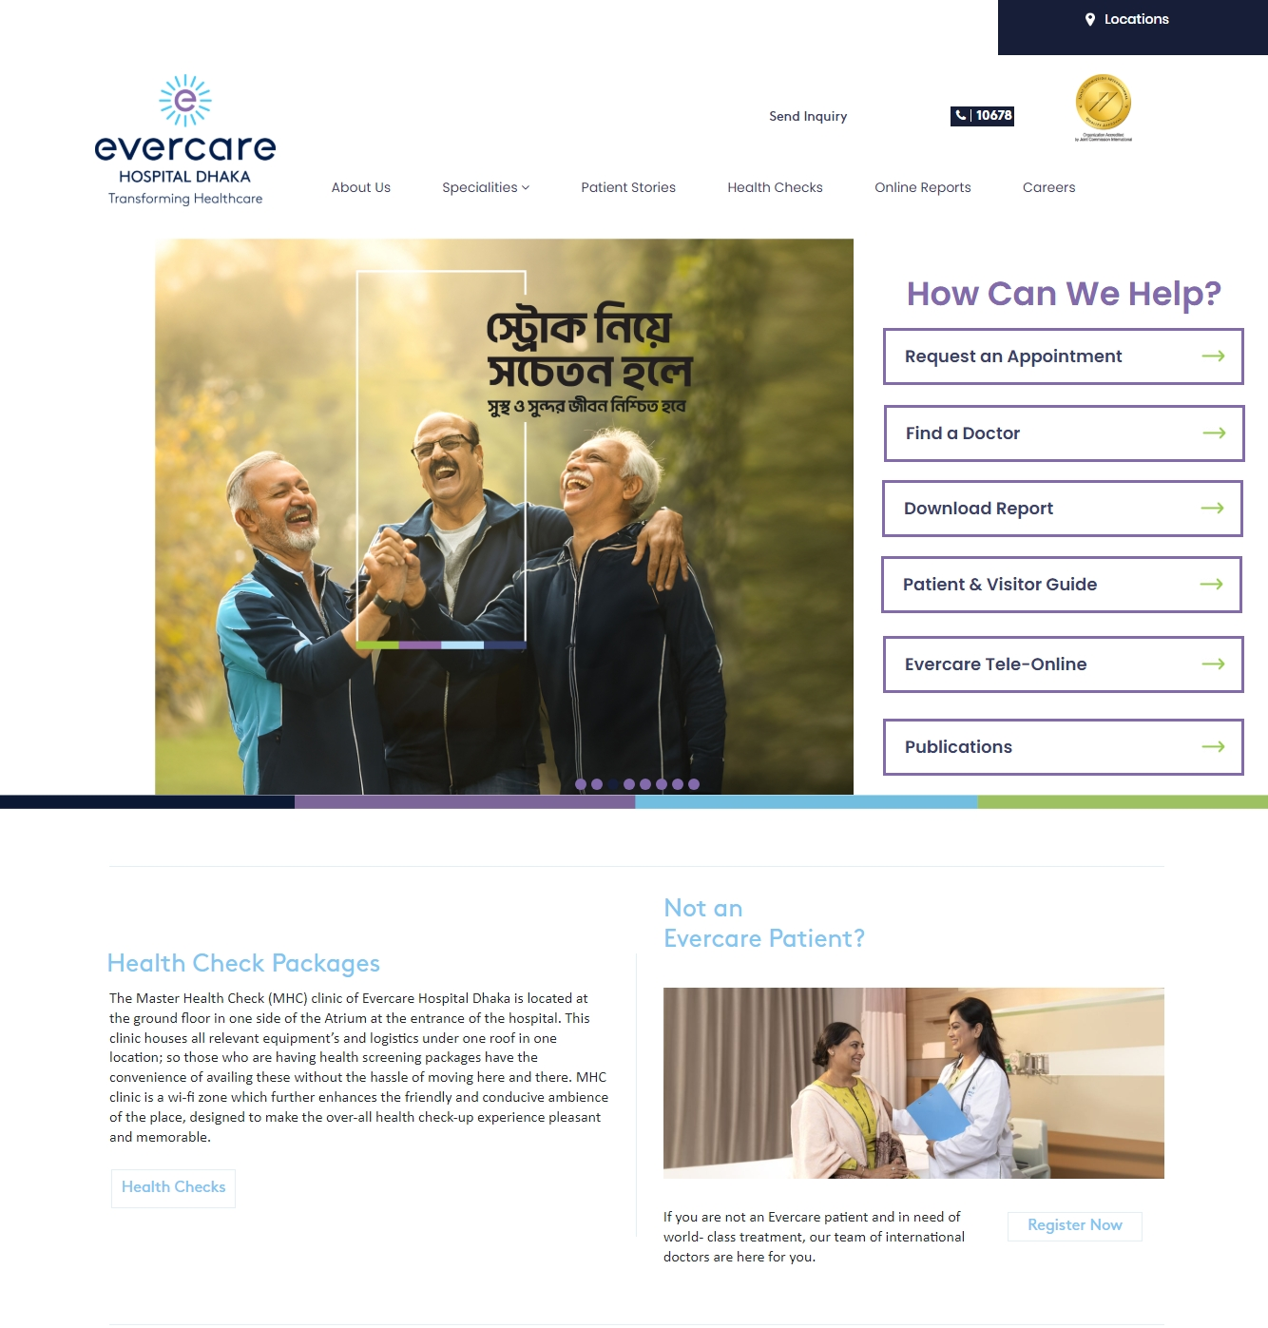

Fig 2.3: Evercare Hospital Dhaka

[4] The oldest tertiary-level hospital in Bangladesh is Dhaka Medical College Hospital (DMCH), which is situated in the center of Dhaka. This hospital began as a 200-bed field hospital for the British Indian military on July 10, 1946. British major WJ Virgin MIS served as the hospital's first overseer, followed by colonel E.G. Montgomery. Constructed in 1904, the main edifice served as the secretariat office for Asham and the Prince of Brinish Colonies. It has a rich history of democratic struggles, such as the Language Movement in 1952 and the Student Form Liberation War in 1971. It is an academic hospital where graduate and post-graduate students from several disciplines at Dhaka Medical College and Dhaka Nursing College have received their practical training.

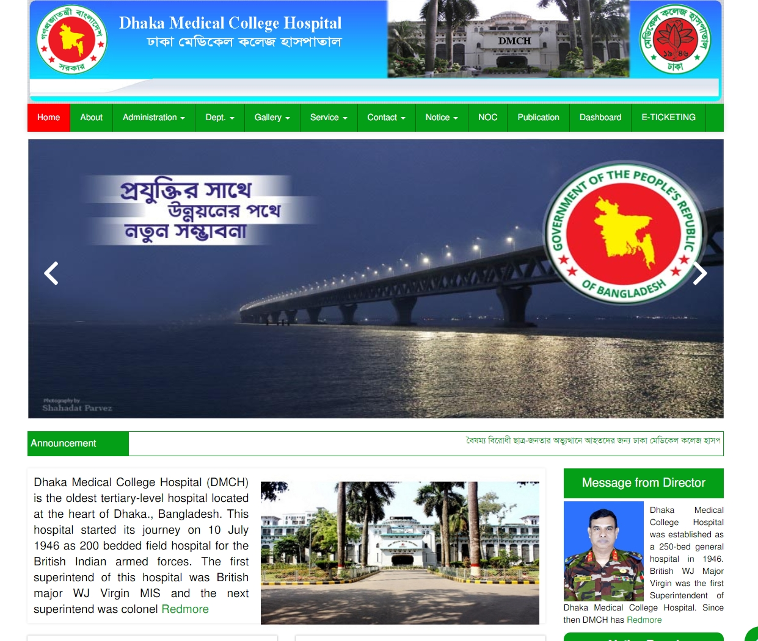

Fig 2.4: Dhaka Medical College Hospital

[5]. As a world-class hospital, BSH provides a wide range of services and specialists, excellent technology and equipment, a friendly atmosphere, and high-quality services. The hospital's use of paperless medical records is a demonstration of how medical technology and ICT Division developments are combining. With the help of state-of-the-art technology and skilled nurses, technologists, and administrators, the medical professionals at Bangladesh Specialized Hospital are able to deliver healthcare that satisfies international standards.

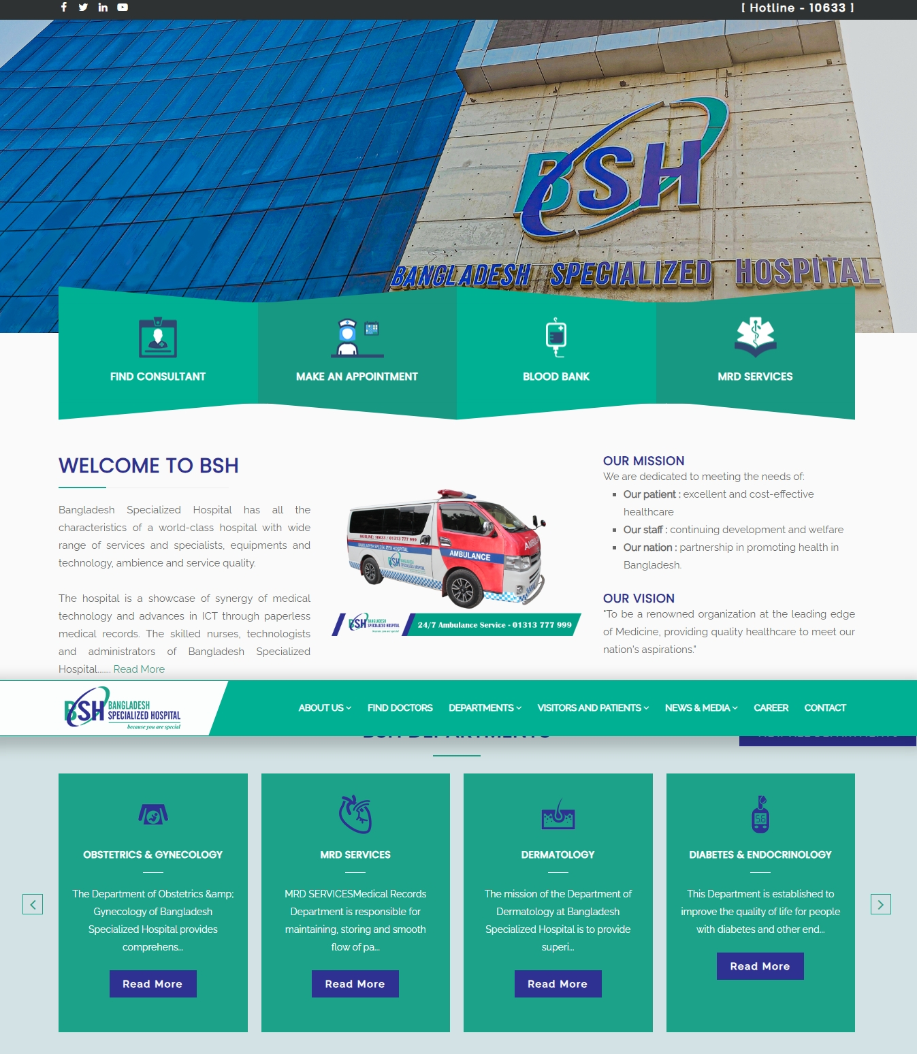

Fig 2.5: Bangladesh Specialized Hospital

[6] In Chittagong, Bangladesh, there is a private hospital called Imperial Hospital Limited, also known as Apollo Imperial Hospitals. Devi Shetty, an Indian cardiac surgeon and businessman, hosted an inauguration event in April 2019 to officially inaugurate IHL.

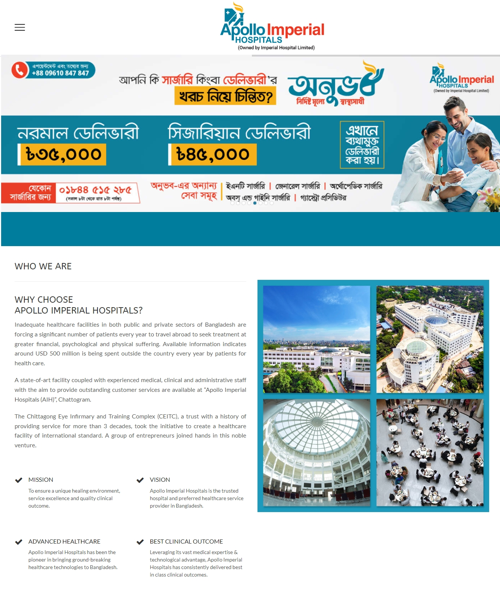

Fig 2.6: Apollo Imperial Hospitals

[7] One of the top private healthcare providers in Bangladesh is Prime Hospital Ltd. Noakhali is where you can find it. Founded in 1996, Prime Hospital Ltd. has been the first modern technology domestic healthcare facility in Bangladesh, operating for more than 27 years. In the wider Noakhali district, it is currently the top multidisciplinary private hospital. World-class integrated healthcare facilities run by highly skilled experts enable Prime Hospital Ltd. to provide comprehensive care and high-quality clinical outcomes, which contribute to its reputation. manned by a sizable group of committed professionals and a wide range of exceptionally talented experts. Prime Hospital Ltd. works to satisfy patients' needs by providing high-quality medical care and improving their quality of life. Up to 1000 patients can be served every day by the hospital's outpatient department (outdoor), which employs more than 90 consultants. Every day during convenient morning, afternoon, and late evening hours, the outpatient service is available. Other than that, our emergency room is open around-the-clock, every day of the year. In addition, a highly qualified team provides exceptional indoor healthcare services with 150 beds. Prime Hospital Ltd. strives to offer the best possible care to the people of Bangladesh in order to provide exceptional service.

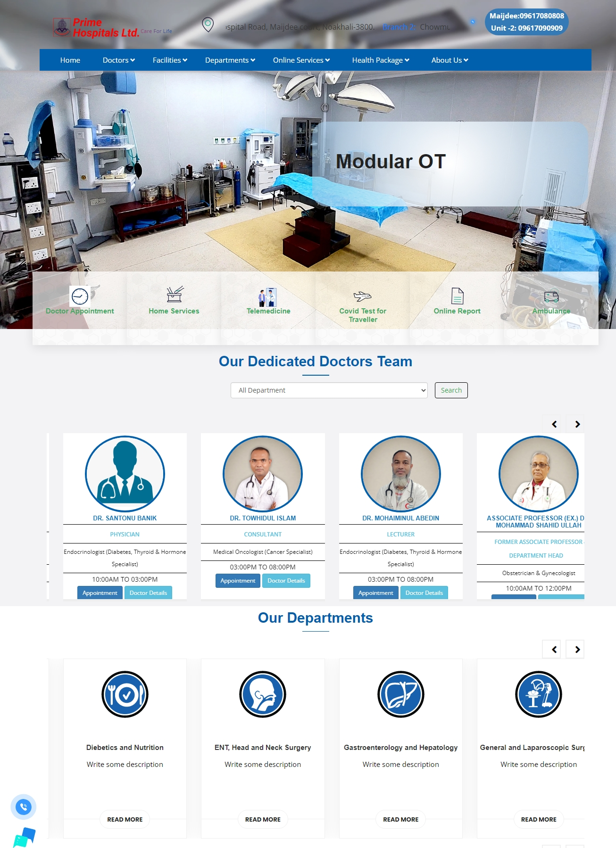

Fig 2.7: Prime Hospital Ltd.

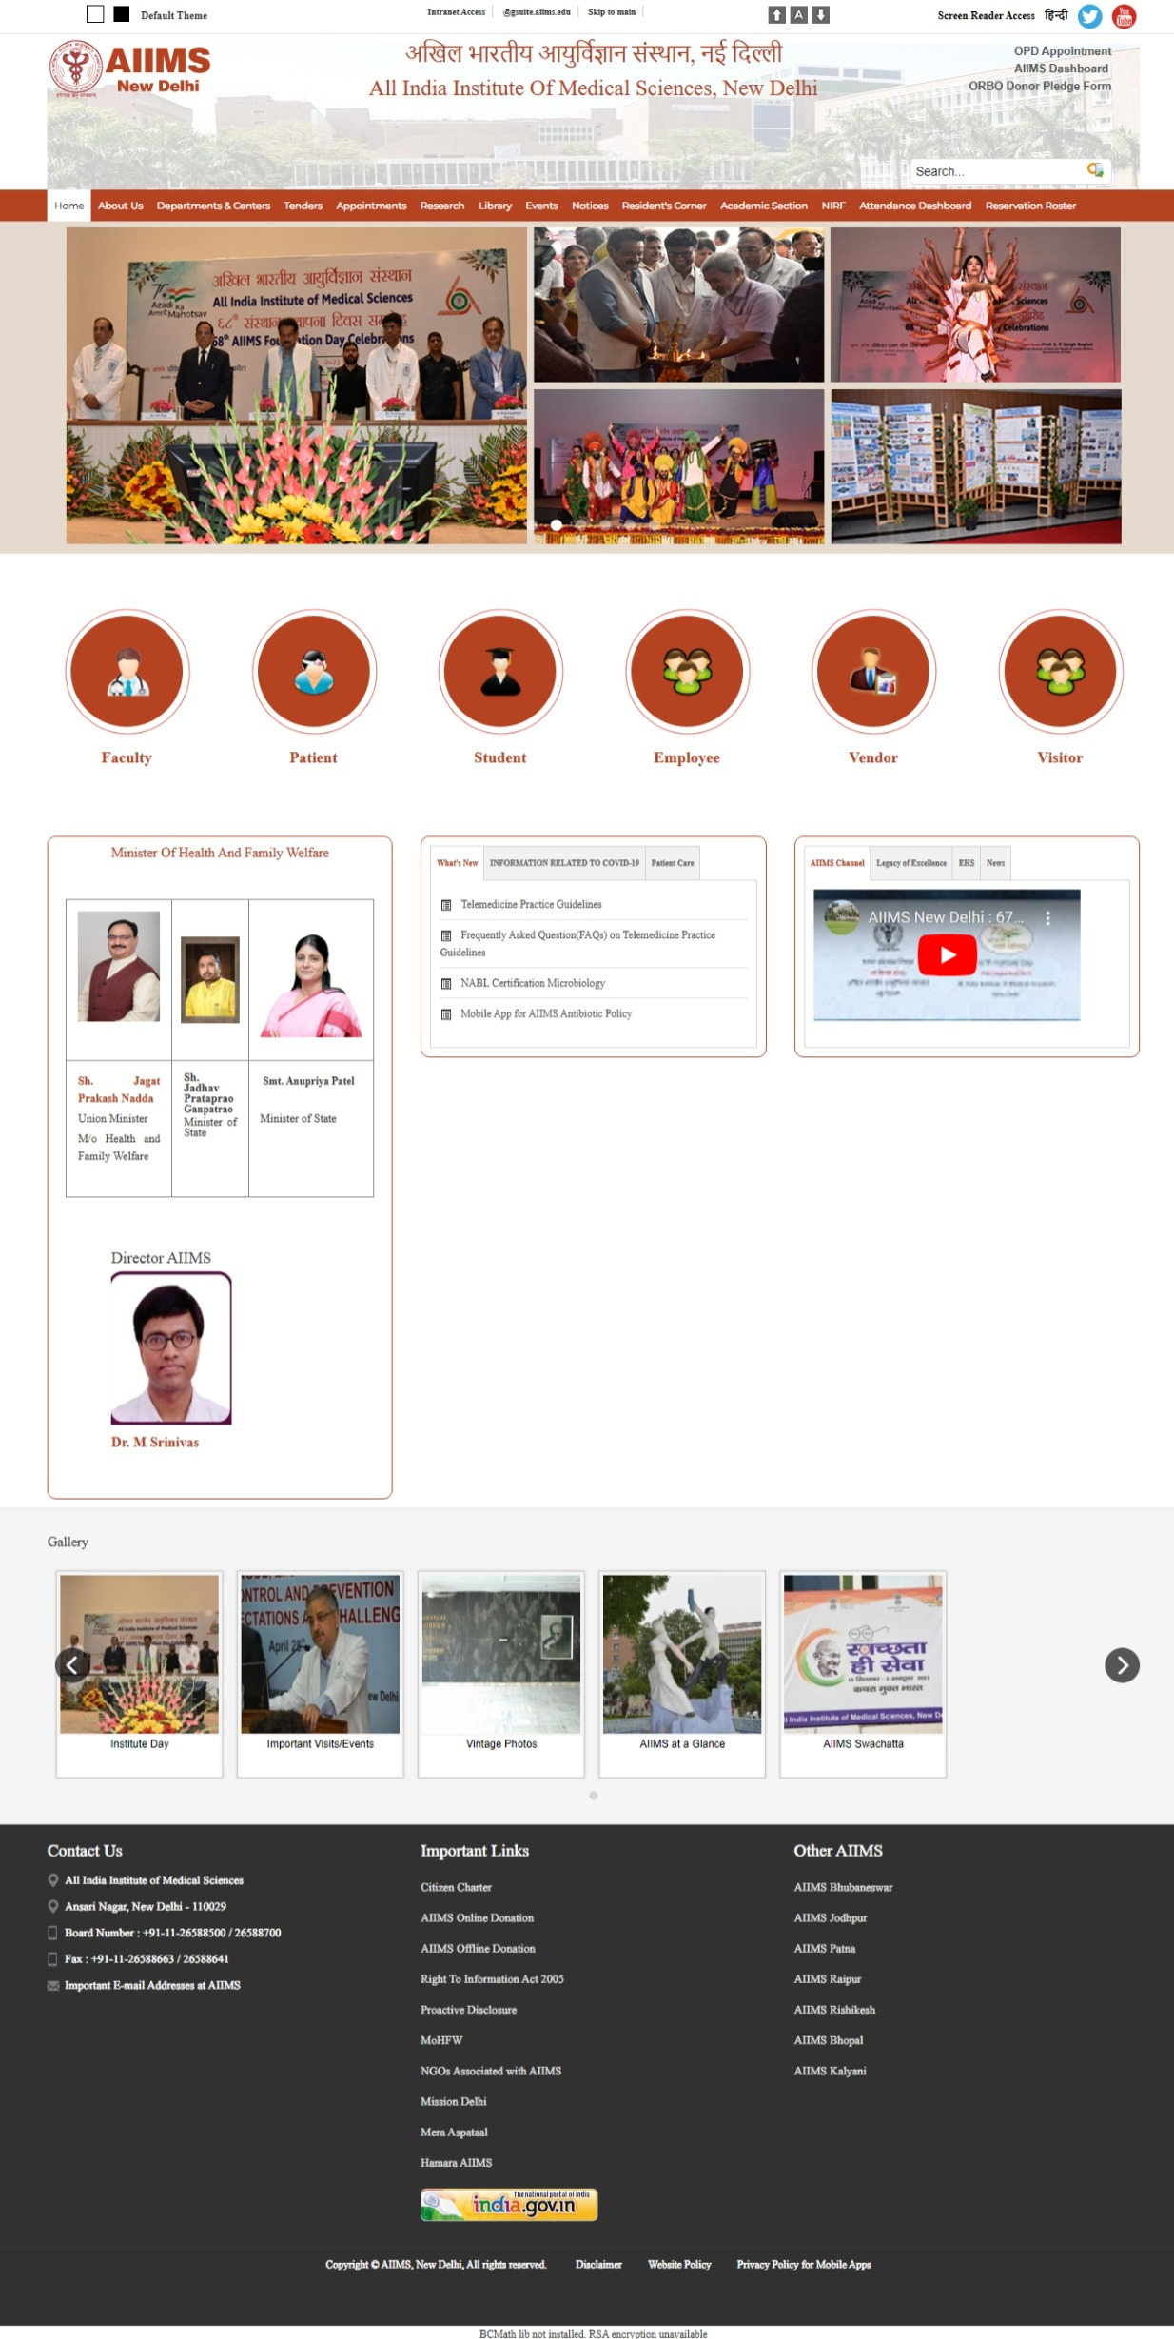

Fig 2.8: All India Institute of Medical Sciences

[9] In the United States, the Mayo Clinic is a private academic medical facility that prioritizes integrated healthcare, education, and research. Its three main campuses are located in Rochester, Minnesota; Jacksonville, Florida; and Phoenix/Scottsdale, Arizona.

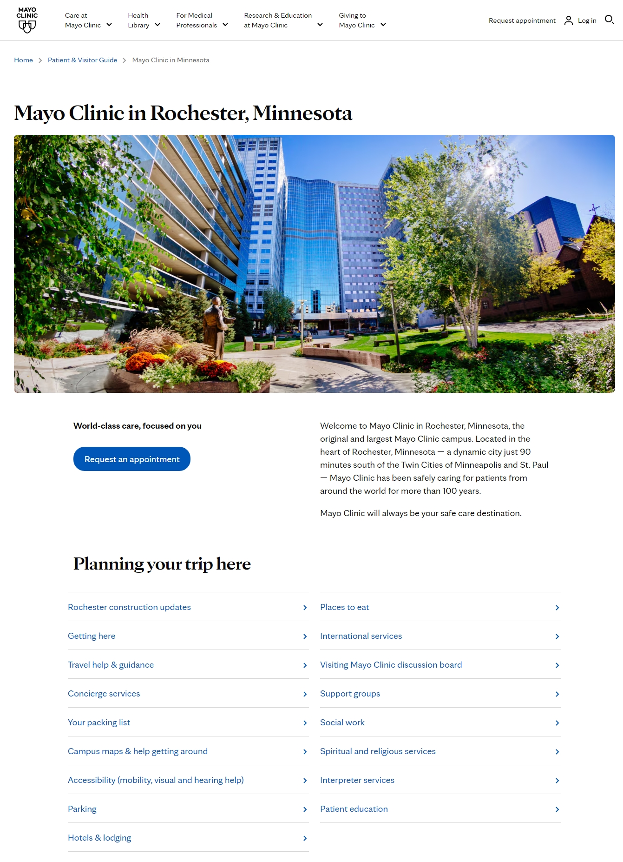 Fig 2.9: Mayo Clinic in Rochester, Minnesota

**This section include a summary of related project on hospital management system.**

|  |  |  |  |
| --- | --- | --- | --- |
| Hospital Name | Location | Key Specialties | Notable Features |
| BIRDEM General Hospital | Dhaka, Bangladesh | Diabetes, Endocrinology, Metabolic Disorders | 600-bed facility; treats approximately 3,500 outpatients daily; designated as a WHO Collaborating Centre on Diabetes. |
| Square Hospital | Dhaka, Bangladesh | Cardiology, Neurology, Orthopedics, Oncology | 400-bed capacity; known for modern medical facilities and advanced equipment. |
| Evercare Hospital Dhaka | Dhaka, Bangladesh | Cardiology, Orthopedics, Neurosurgery, Urology | 425-bed multidisciplinary super-specialty tertiary care hospital; first in Bangladesh to receive JCI accreditation. |
| Dhaka Medical College Hospital | Dhaka, Bangladesh | General Surgery, Cardiology, Oncology, Neurology | One of the oldest and largest public hospitals in Bangladesh; 2,300-bed facility; serves around 3,500 inpatients at a time. |
| Bangladesh Specialized Hospital | Dhaka, Bangladesh | Cardiology, Gastroenterology, Orthopedics, Neurology | Modern facilities with experienced specialists; focuses on patient care. |
| Apollo Imperial Hospitals | Chittagong, Bangladesh | Multispecialty | Part of Apollo hospital chain with quality services. |
| Prime Hospital Ltd. | Noakhali,  Bangladesh | General Medicine, Surgery | Affordable and reliable healthcare. |
| All India Institute of Medical Sciences (AIIMS) | New Delhi, India | Comprehensive specialties including Cardiology, Neurology, Oncology | Premier medical institute in India; known for advanced research and specialized treatments. |
| Mayo Clinic | Rochester, Minnesota, USA | Comprehensive specialties including Cardiology, Neurology, Oncology | Nonprofit American academic medical center; renowned for integrated healthcare, education, and research; employs over 7,300 physicians and scientists. |

Table 2.1: A summary of related project on HMS.

**Chapter 3**

**METHODOLOGY**

**3.1 Requirement Engineering**

Requirement gathering focuses on understanding stakeholder needs, requirements that are both functional (like patient administration and billing) and non-functional (such security and scalability). This involves conducting interviews, surveys, and analysis of existing systems to ensure the new HMS meets all necessary criteria. The requirement engineering process includes:

* **Stakeholder Analysis:** Identifying key stakeholders such as doctors, nurses, administrative staff, and patients to gather specific needs.
* **Requirement Elicitation:** Collecting data through interviews, questionnaires, and workshops.
* **Requirement Documentation:** Creating detailed requirement specification documents.
* **Requirement Validation:** Ensuring that all collected requirements align with the hospital's operational goals and regulatory standards.

**3.2 Proposed Process Model**

The HMS will follow an iterative development process, ensuring continuous feedback and incremental improvements. The chosen model will allow flexibility and adaptability to changes during development. The process will consist of the following stages:

The Hospital Management System, An organized method for outlining the steps, tasks, and interactions involved in developing a software application is called a process model. To develop of this system we need to follow an iterative development process model.

**Agile Model:**

[17] The Agile Model was designed to help projects quickly adapt to requests for change. So, the main objective of the Agile methodology is to expedite project completion. To perform this task, agility is required. Agility is obtained by removing processes that may not be required for a particular project and tailoring the process to the project. Wasteful actions of time and effort are also avoided. The Agile Model is a system of development processes. These procedures have a number of essential characteristics, despite some little differences.

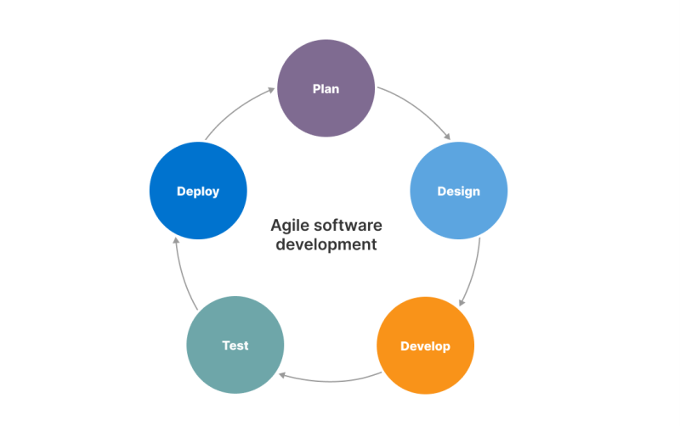

Figure 3.1: Agile Software Development Model.

**3.3 Technologies and Tools**

To create this project using MongoDB, Express.js, React.js, Node.js is a feasible and effective choice that offering scalability, flexibility, and a modern development experience. Using the MERN stack, we will need a combination of frontend development, backend development, database management, security, deployment and monitoring.

**Core Tools and Technologies:**

**Technologies for client-side scripting:**

* Hypertext Markup Language, or HTMLCSS(Cascading Style Sheets)
* The CSS Framework's Bootstrap
* Javascript
* Javascript Framework Library, or React Js

**Technologies for server-side scripting:**

* Express.js(for building RESTful APIs)
* Node.js(server-side javaScript runtime)

**Database Related Tools:**

* NoSQL database MongoDB
* MongoDB ODM (Mongoose)

**System for hosting and version control:**

* Heroku(for free hosting for small scale tesing)
* Vercel(with serverless Functions MERN stack for limited backend logic)
* GIT(for version control system)

(i)**HTML:**

The internet's most basic building block is HTML, or HyperText Markup Language. Web content determines its structure and meaning. Most of the time, technologies other than HTML are used to describe the design and presentation (CSS) or functionality and behavior (JavaScript) of a web page. In [9]

"Hypertext" is the term used to describe links that connect online pages within or between websites. Links are among the Web's essential components. An active participant in the World Wide Web is someone who adds content to the Internet and links to other people's pages.

**(ii) CSS:**

**To define the presentation of an HTML or XML document (including XML dialects like SVG, MathML, or XHTML), a stylesheet language known as Cascading Style Sheets (CSS) is utilized. CSS defines the appearance of elements in text, speech, screens, and other media.[10]**

(iii) **Bootstrap:**

A free and open-source front-end programming framework for building websites and online applications is called Bootstrap. The goal of the template design vocabulary provided by Bootstrap is to make it easier to Make webpages that are optimized for mobile devices.All developers have to do is add code to an existing grid system because A framework called Bootstrap offers the foundation for adaptable web development. The core components of the Bootstrap system are JavaScript, HTML, and cascade style sheets (CSS). Web developers can design websites much more rapidly and without having to spend time considering basic features and commands by using Bootstrap.[11]

# **(iv) JavaScript:**

First-class functions are included in JavaScript (JS), a straightforward interpreted (or just-in-time constructed) programming language. Web page scripting is its most well-known use, although it is also utilized in various non-browser contexts, such as Apache CouchDB, Node.js, and Adobe Acrobat. JavaScript supports imperative, object-oriented, and declarative programming techniques, including functional programming. It is a single-threaded, dynamic language with multiple paradigms that is prototype-based.[12]

## **(v) React:**

**Web user interfaces (UIs) are created using the React library in JavaScript.. Programmers may develop reusable user interface elements with React, a declarative, component-based framework. To increase rendering speed, it makes advantage of the Virtual DOM (Document Object Model) method, which reduces DOM updates. React is fast and easily combines with other technologies and libraries.[13]**

(vi) **Node.js:**

Node.js is an open-source, cross-platform environment for running JavaScript. It is a popular tool for almost every kind of assignment! Google Chrome's V8 JavaScript engine is powered by Node.js outside of the browser. This makes Node.js's fast performance possible. Instead of starting a new thread for each request, a Node.js application operates in a single process.. In Node.js libraries, blocking behavior is the exception rather than the rule because non-blocking paradigms are usually used in their design. Additionally, a set of asynchronous I/O primitives that stop JavaScript code from blocking are included in the standard library of Node.js.[14]

(vii) **Express.js:**

Express JS is a Node.js web development platform. This framework can be used to construct single-page, multi-page, and hybrid web applications. It manages servers, routes, asynchronous, single treads, and more. It also offers faster input/output. It facilitates end-to-end, integration, and unit testing. With the help of this framework, you can quickly scale your application and use JS for both front-end and back-end development. The Google v8 engine supports it, which improves its performance [14].

(viii) **MongoDB:**

An open source NoSQL database management solution is called MongoDB.. It is possible for NoSQL (not just SQL) to replace conventional relational databases. NoSQL databases greatly simplify the process of working with large, scattered data sets. MongoDB can be used to organize, store, and retrieve document-oriented data. Businesses can swiftly store vast volumes of data because to MongoDB's high-volume data storage capabilities. Ad hoc queries, indexing, load balancing, aggregation, server-side JavaScript execution, and other functionalities are some of the additional reasons why companies adopt MongoDB [15].

(ix) **Mongoose:**

Mongoose is an object data modeling (ODM) module for Node.js and MongoDB. It manages data relationships, provides schema validation, and converts between coded things and their MongoDB representations [16].

**Software Requirements:**

1. Operating System: Linux, Windows XP or Later
2. Browser: Google Chrome, Firefox
3. Editor: Notepad++, Visual Studio Code, Sublime Text or any text editor.

**Hardware Requirements:**

* Processor: Standard Processor
* RAM: 2 GB RAM or more
* Hard Disk: 50 GB or more
* Monitor: Standard Monitor
* Keyboard: Standard Keyboard
* Mouse: Standard Mouse

**Requirement for Windows:**

* 64-bit Microsoft® Windows® 8/10
* X86_64 CPU architecture; 2nd generation Intel Core or newer, or AMD CPU with support for a windows Hypervisor
* 8 GB Ram or more
* 8 GB of available disk space minimum (IDE + Android SDK + Android Emulator)
* 1280 x 800 minimum screen resolution

**3.4 Use Case Diagram**

A Use case Diagram are used to represent the visual representation of how users, doctors and admin are interact the system with respect to system requirement. Here the key entities are actors which are represent as patients, doctors and admin and they connected with system functionalities using connecting lines.

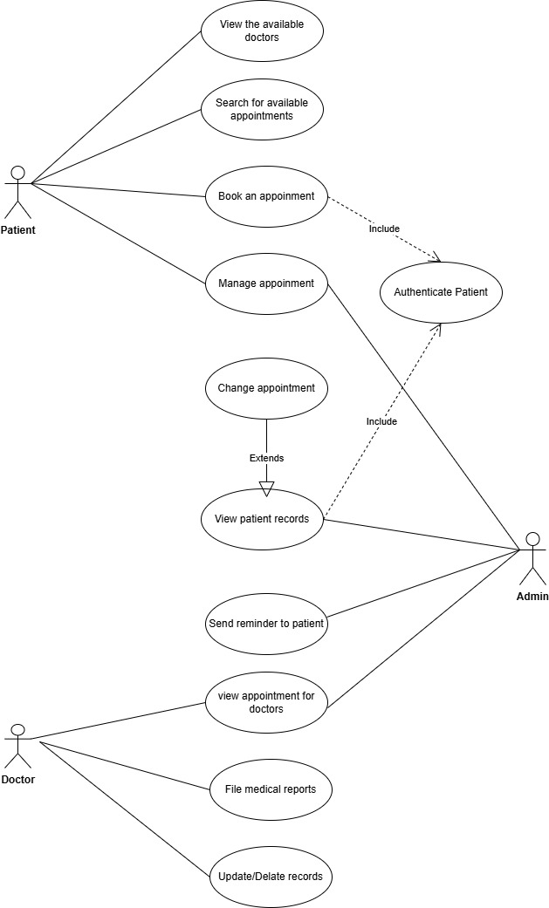

Fig 3.2: Use Case Diagram Web based hospital management System

**3.5 E-R Diagram**

The entity-relationship model defines relationships between patients, doctors, staff, and departments. Key entities include:

* **Patients:** Linked to appointments, billing, and medical history.
* **Doctors:** Associated with schedules, prescriptions, and patient records.
* **Hospital:** Managing staff and services.
* **Medical Records:** Tracking usage and availability of medical supplies.

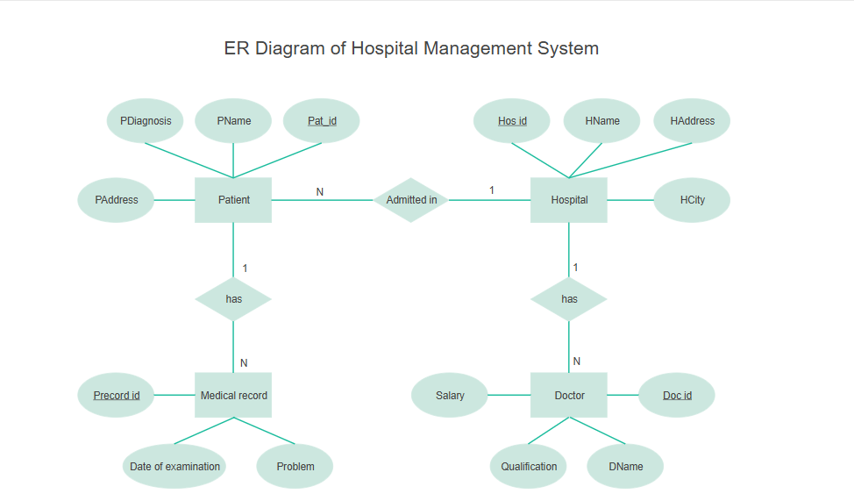

Fig 3.3: ER diagram of Hospital Management System

**3.6 Testing**

Testing strategies include:

* **Unit Testing:** Verifying the functionality of individual components.
* **Integration Testing:** Ensuring seamless communication between different system modules.
* **System Testing:** Evaluating the complete system for compliance with requirements.
* **User Acceptance Testing (UAT):** Gaining approval from end-users by validating real-world functionality.
* **Security Testing:** Assessing vulnerabilities and ensuring data protection measures.

**3.7 Maintenance**

Ongoing system maintenance will address updates, performance enhancements, and security patches. The maintenance strategy includes:

* **Corrective Maintenance:** Fixing identified bugs and performance issues.
* **Adaptive Maintenance:** Updating the system to comply with new regulations and hospital policies.
* **Preventive Maintenance:** Regular system audits to avoid future issues.
* **Enhancements:** Adding new features based on user feedback and technological advancements.

**Chapter 4**

**EXPECTED OUTPUT**

The implementation of the **Hospital Management System (HMS)** is set to bring about transformative changes, enhancing efficiency and improving healthcare delivery. Below are the anticipated benefits:

**1. Operational Efficiency**

* Automation of administrative tasks to **minimize workload** and **enhance workflow** across departments.
* Seamless data flow that reduces **manual errors** and optimizes hospital operations.
* Real-time tracking of hospital operations, reducing dependency on manual interventions.
* Improved coordination between departments, ensuring a holistic approach to healthcare delivery.
* Reduction in redundant data entry efforts, ensuring a more streamlined operation.

**2. Patient Satisfaction**

* Faster processing, **reduced waiting times**, and improved communication channels.
* Online appointment scheduling, easy access to medical records, and timely notifications for visits and medications.
* Personalized health alerts and reminders based on patient history.
* Enhanced transparency in patient care, with access to treatment plans and progress reports.
* User-friendly patient portals for accessing reports, prescriptions, and appointment tracking.

**3. Cost Savings**

* Significant reduction in administrative expenses through paperless operations and automation.
* Optimized resource allocation, leading to improved **financial efficiency**.
* Reduced overhead costs by minimizing paperwork, storage, and manual labor.
* Automated insurance claims processing to reduce rework and expedite settlements.

**4. Regulatory Compliance**

* Full adherence to global healthcare regulations such as **HIPAA** and **GDPR**.
* Secure patient data management with proper **audit trails** and privacy controls.
* Regular compliance audits to ensure regulatory requirements are met without gaps.
* Role-based access control to ensure data integrity and confidentiality.

**5. Scalability**

* The system is **highly adaptable**, accommodating future expansion and additional features.
* Supports multiple hospital branches, departments, and third-party integrations such as **insurance providers** and **telemedicine services**.
* Modular architecture to easily integrate future technological advancements and functionalities.

**6. Security**

* Implementation of robust **encryption protocols** and **role-based access control**.
* Real-time security monitoring and multi-factor authentication to safeguard sensitive data.
* Regular system updates and patches to protect against potential cyber threats.
* Automated alerts for suspicious activities and unauthorized access attempts.

**7. Data-Driven Decision Making**

* Advanced analytics and reporting features to support **strategic hospital planning**.
* Comprehensive dashboards showcasing **Key Performance Indicators (KPIs)** for efficient resource management.
* Predictive analytics to anticipate patient inflows, resource needs, and inventory planning.
* Customizable reporting tools to generate insights for hospital management.

**8. Interoperability**

* Seamless integration with various healthcare systems such as:
  + **Laboratory Information Management Systems (LIMS)**
  + **Pharmacy Management Systems**
  + **Government Health Databases**
* Enhanced coordination and data sharing across the healthcare ecosystem.
* Standardized data exchange formats to improve compatibility with external systems.

**9. Enhanced User Experience**

* A highly intuitive and user-friendly interface designed for:
  + Healthcare professionals
  + Administrative staff
  + Patients
* Ensuring **ease of navigation** and accessibility for all users.
* Responsive design for access via desktops, tablets, and smartphones.
* Multilingual support to cater to diverse patient demographics.

**10. Customization**

* The system offers **tailored solutions** for various healthcare facilities, including:
  + Specialty clinics
  + Multi-specialty hospitals
  + Diagnostic centers
* Custom workflow configurations to meet specific operational needs.
* Flexible integration with third-party applications and existing hospital software.

**11. Disaster Recovery**

* Cloud-based backup solutions to ensure rapid **data recovery** in case of:
  + System failures
  + Cyber incidents
* Ensuring continuous and uninterrupted healthcare operations.
* Redundancy planning to prevent data loss during unforeseen events.
* Regular backup schedules to maintain up-to-date data copies.

**Chapter 5**

**CONCLUSION**

**5.1 Conclusion**

The proposed Hospital Management System (HMS) aims to revolutionize hospital management by integrating various functions into a unified platform. The system promises to enhance efficiency, ensure patient data security, and provide comprehensive support for hospital operations. By offering features such as patient data management, automated billing, appointment scheduling, and inventory tracking, the system will streamline workflows, reduce administrative burdens, and improve overall patient care.

Furthermore, the implementation of an HMS will facilitate better resource allocation, enable real-time monitoring, and enhance decision-making capabilities for hospital administrators. Hospitals can expect significant improvements in patient satisfaction, compliance with healthcare regulations, and financial management. The deployment of an HMS also ensures that healthcare providers can focus more on patient care rather than administrative tasks.

Despite the numerous benefits, the implementation of an HMS comes with challenges such as training staff to use the system effectively, ensuring seamless integration with existing infrastructure, and managing data migration processes. However, with proper planning, stakeholder involvement, and continuous system evaluation, these challenges can be mitigated to ensure a successful implementation.

**5.2 Future Work**

To further improve the capabilities of the Hospital Management System, future enhancements may include:

* **Integration with Wearable Health Devices:** Enabling real-time patient monitoring and remote tracking of vital signs to provide proactive healthcare interventions.
* **AI-Based Predictive Analytics:** Utilizing artificial intelligence to analyze patient data for early disease detection, risk assessment, and personalized treatment plans.
* **Mobile Application Development:** Introducing mobile applications for both patients and healthcare providers to facilitate better communication, appointment scheduling, and remote consultations.
* **Multi-Language Support:** Expanding language options to cater to diverse patient populations, ensuring accessibility and inclusivity for non-native speakers.
* **Blockchain Integration:** Implementing blockchain technology to enhance data security, ensure data integrity, and enable transparent access control.
* **Telemedicine Capabilities:** Incorporating telehealth features to allow virtual consultations, remote diagnosis, and expanded healthcare access in rural and underserved areas.
* **Automated Reporting and Compliance Tracking:** Developing features to generate compliance reports automatically and track adherence to healthcare regulations such as HIPAA and GDPR.
* **Patient Feedback System:** Creating a feedback mechanism that allows patients to provide insights and ratings, aiding hospitals in continuous service improvement.
* **Interoperability with National Health Systems:** Ensuring seamless communication with government health initiatives and databases for efficient data exchange and reporting.
* **Enhanced Data Visualization:** Introducing advanced dashboards and graphical representations for better insight into hospital operations and performance metrics.

By adopting these future enhancements, the Hospital Management System will continue to evolve, addressing emerging challenges in healthcare management and ensuring better outcomes for patients and healthcare providers alike.

**REFERENCES:**

1. https://birdembd.org**/**, Accessed 15 January 2025
2. **.** https://squaregroup.com/about-us/, Accessed 15 January 2025
3. https://www.evercarebd.com/dhaka/about-us**/**, Accessed 15 January 2025
4. https://dmch.gov.bd/about/dhaka-medical-college-hospital**/**, Accessed 15 January 2025
5. https://www.bdspecializedhospital.com/about/about-bshl, Accessed 15 January 2025
6. https://aihlbd.org**/**, Accessed 15 January 2025
7. https://www.primehospitalltd.com/, Accessed 15 January 2025
8. https://www.aiims.edu/index.php/en/about-us/2019-02-06-05-47-04, Accessed 15 January 2025
9. https://devdocs.io/html/, Accessed 20 January 2025

[10].https://developer.mozilla.org/en-US/docs/Web/CSS, Accessed 20 January 2025

[11].https://www.techtarget.com/whatis/definition/bootstrap, Accessed 20 January 2025

[12]. https://developer.mozilla.org/en-US/docs/Web/JavaScript, Accessed 20

[13]. https://nodejs.org/en/learn/getting-started/introduction-to-nodejs, Accessed 20 January 2025

[14]. https://www.browserstack.com/guide/web-development-tools, Accessed 20 January 2025

[15]. https://www.techtarget.com/searchdatamanagement/definition/MongoDB Accessed 20 January 2025

[16]. https://www.freecodecamp.org/news/introduction-to-mongoose-for-mongodb- d2a7aa593c57/ Accessed 20 January 2025

[17]. https://www.geeksforgeeks.org/software-engineering-agile-development-models/, Accessed 25 January 2025